

SAIS Forecaster Application: Snowpack evaluation task.

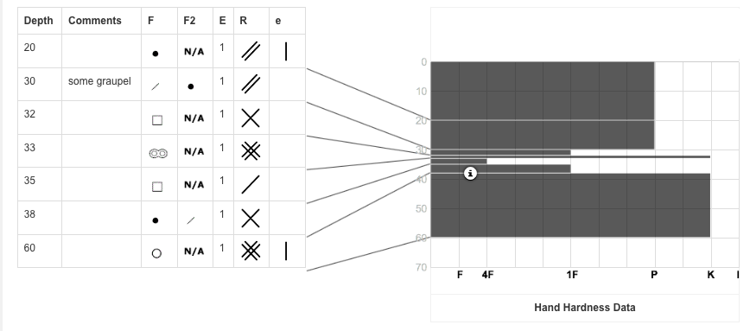Please complete and send with your application to training@sais.gov.uk

|  |
| --- |
| Referring to the above snow profile data please answer the following questions: |
| Question 1: Please describe the timeline of weather conditions and snow factors that produced the above snow profile ? |
|  |
| Question 2: If the weather forecast indicated freezing levels above summits and summit rain at the snow profile location for 6hrs, then dry with freezing levels remaining at summit levels, what would you consider the effect on snow stability to be ? |
|  |